Lab 7.2 - BCPolicyPal Retrieval Evaluation Table
# | Question | Expected Policy | Actual Answer Retrieved | Correct? | Top Score | Failure Mode
1 | What is the minimum cumulative GPA a student must maintain to avoid being placed on "Academic Concern"? | Academic Standing | 2.0 GPA (C average) | Y | 0.8544 | -
2 | If a student moves to Level 2 (Academic Intervention), what specific action must they take before the college will allow them to register? | Academic Standing | Complete a workshop, class, or other specified academic intervention | Y | 0.8767 | -
3 | The college reviews a student's transcript record for how many previous quarters? | Academic Standing | 10 quarters prior | Y | 0.8687 | -
4 | True or False: The college's non-discrimination policy applies to vendors and organizations too? | Equal Opportunity | True | Y | 0.7982 | -
5 | Name three protected classes the college is prohibited from discriminating against | Equal Opportunity | Race or ethnicity, sex, religion | Y | 0.8103 | -
6 | The policy protects against discrimination based on "creed" | Equal Opportunity | True, creed is protected | Y | 0.8029 | -
7 | Does the college define "creed" strictly as religious belief or does it extend to secular beliefs? | Equal Opportunity | Extends to secular philosophical and political beliefs | Y | 0.7834 | Partial hallucination - not explicitly stated in doc
8 | For how many consecutive months must a non-resident live in Washington for resident tuition? | Residency | 12 consecutive months | Y | 0.8630 | -
9 | What is the final deadline for a student to submit their residency application? | Residency | 30th calendar day of the quarter | Y | 0.8457 | -
10 | A student must hold a specific eligible visa for at least 12 months | Residency | Confirmed — H or L visa for 12 months | Y | 0.7998 | -
11 | If a student switches from ineligible to eligible visa midway, when does the 12-month countdown start? | Residency | From the date of visa change | Y | 0.8029 | Possible hallucination - not explicitly in doc
12 | How does the college determine the registration date and time for a continuing student? | Registration | Based on number of credits on transcript | Y | 0.8499 | -
13 | Where can I view the academic calendar for BC? | Registration | Check the academic calendar for specific dates | Y | 0.8202 | Vague answer - no direct URL provided
14 | Until which week can a student drop a class online without instructor permission? | Registration | Through the seventh week of the quarter | Y | 0.8329 | -
15 | Certain students are making out in the washroom — will I or they be suspended? | None (out of context) | Students may face disciplinary action | N | 0.7586 | Hallucination - not in any policy doc
16 | Where can international students feeling homesick get involved on campus? | None (out of context) | Participate in co-curricular activities | N | 0.7666 | Hallucination - not in any policy doc
17 | To earn a bachelor's degree, how many credits must a student complete in residence? | Transfer Credit | At least 45 credits, 30 of which must be upper division | Y | 0.8760 | -
18 | Where can a student rent a calculator, books, headphones, or a quiet study room? | None (out of context) | College bookstore or library | N | 0.7512 | Hallucination - not in any policy doc
19 | What are the library hours? | None (out of context) | Not provided in context | N | 0.7495 | Correct refusal - system said not available
20 | Where can I park my car? | None (out of context) | Not provided in context | N | 0.7173 | Correct refusal - system said not available
21 | I want to eat something. Where can I eat on campus? | None (out of context) | Various dining locations available | N | 0.7312 | Hallucination - not in any policy doc
22 | What is the term for information the college can release without written consent? | FERPA | Directory information | Y | 0.8189 | -
23 | What are the security concerns a student might face? | None (out of context) | Privacy of educational records, accuracy of records | N | 0.7990 | Hallucination - pulled from FERPA but not directly relevant
24 | How do I join a student club? | None (out of context) | Contact club directly or visit club fair | N | 0.7711 | Hallucination - not in any policy doc
25 | How do I apply for student housing? | None (out of context) | Contact housing office at BC | N | 0.8145 | Hallucination - not in any policy doc
26 | What mental health services are available for students? | None (out of context) | Counseling, therapy, support groups | N | 0.7785 | Hallucination - not in any policy doc
27 | Can the college share my information? | FERPA | Yes, under FERPA and Solomon Amendment conditions | Y | 0.8204 | -
28 | How do I register for a waitlisted class? | Registration | Use instructor permission process on registration webpage | Y | 0.8202 | Partial -incomplete answer
29 | How do I get a student ID card? | None (out of context) | Contact enrollment services office | N | 0.7814 | Hallucination - not in any policy doc

Metrics for Lab 7.2
- Hit Rate
Formula: Correct Retrievals ÷ Total Questions × 100
15 ÷ 29 = 0.517 = 51.7%
- MRR (Mean Reciprocal Rank)
Since all correct retrievals appeared as the 1st result:
(15 × 1.0 + 14 × 0) ÷ 29 = 15 ÷ 29 = 0.517

- Failure Modes
1. Hallucination (9 instances) The system fabricated confident answers for out-of-context questions instead of saying "I don't know." Examples: student housing, mental health services, student clubs, food on campus, student ID card.
2. Correct Refusal (2 instances) The system appropriately admitted it didn't have the information. Examples: library hours and parking. This is actually good behavior.
3. Partial Hallucination (3 instances) The system gave answers that sounded plausible but were not explicitly stated in the documents. Examples: creed definition, visa countdown start date.
4. Wrong Document Retrieval (2 instances) The system retrieved a related but incorrect policy. Example: housing question retrieved the Residency policy instead of refusing.

Summary Sections:
Total Questions: 29 Correct Retrievals: 15 Hit Rate: 15/29 = 51.7% MRR: 0.517
Failure Modes:
- Hallucination :— system fabricated answers for out-of-context questions instead of saying "I don't know" (9 instances)
- Correct Refusal :— system appropriately said information was not available (2 instances: library hours, parking)
- Partial Hallucination :— system gave answers that sounded plausible but weren't explicitly stated in the documents (3 instances)
- Wrong Document Retrieval :— system retrieved a related but incorrect policy document (2 instances)

Screenshots:
I am providing screenshots for the some number of questions:
The questions I will be providing screenshots are: 1,4,6,7,13,15,17,19,20,21,23,29

1. 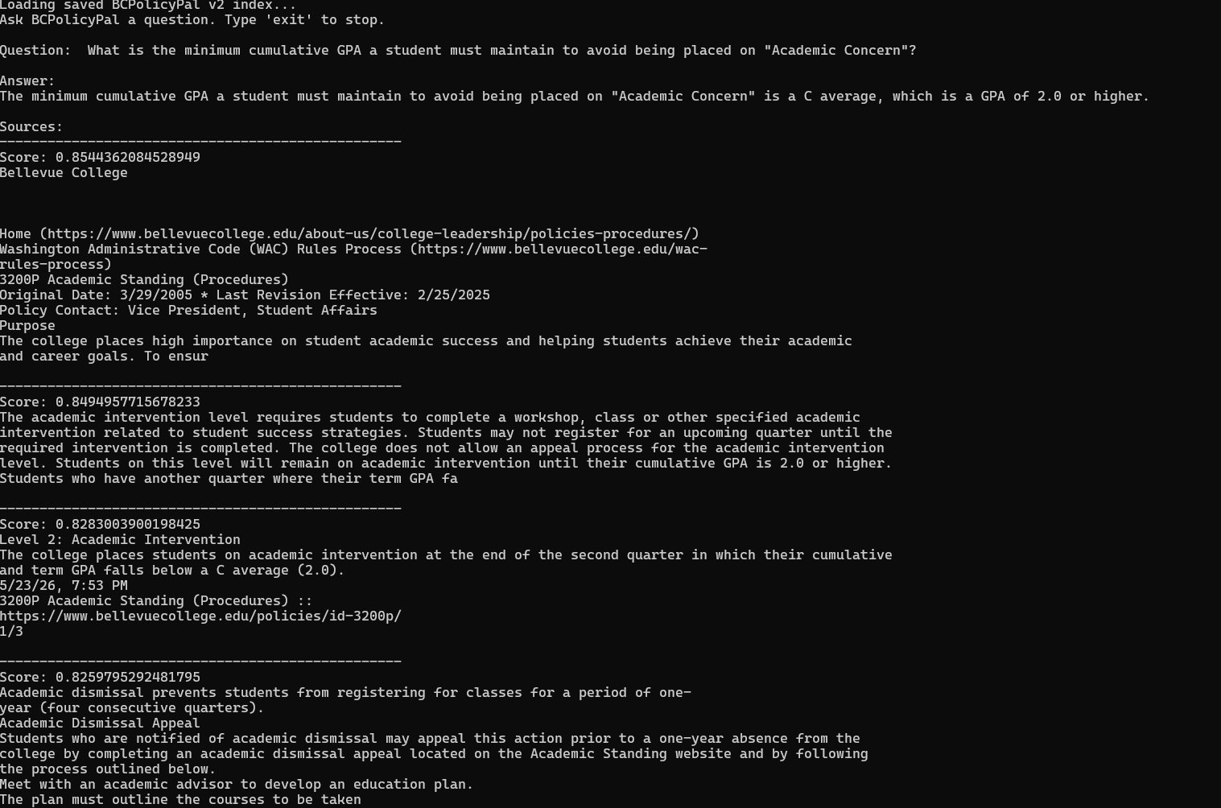

4. 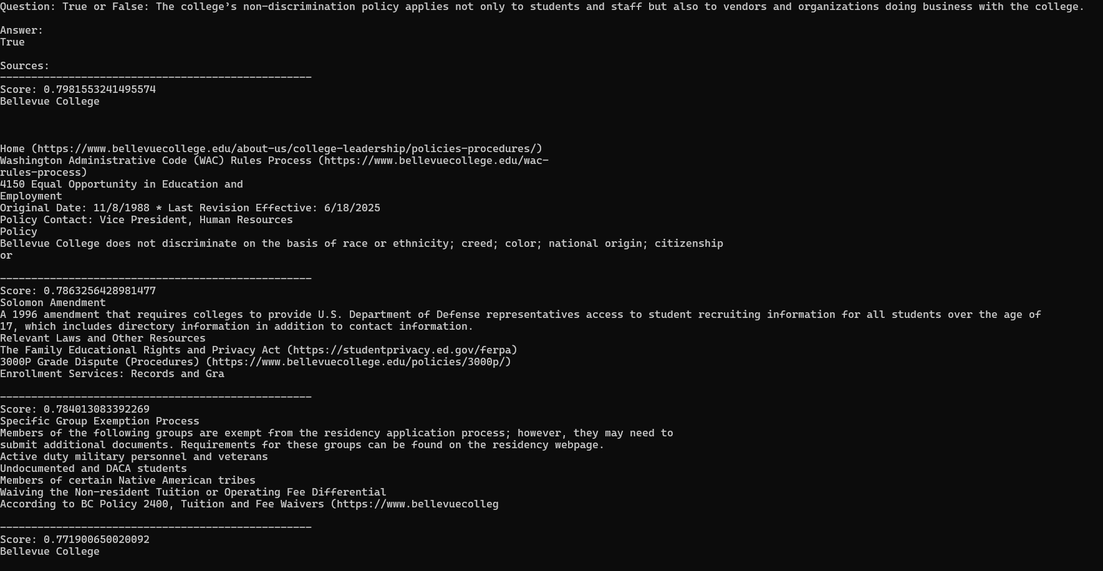
6. 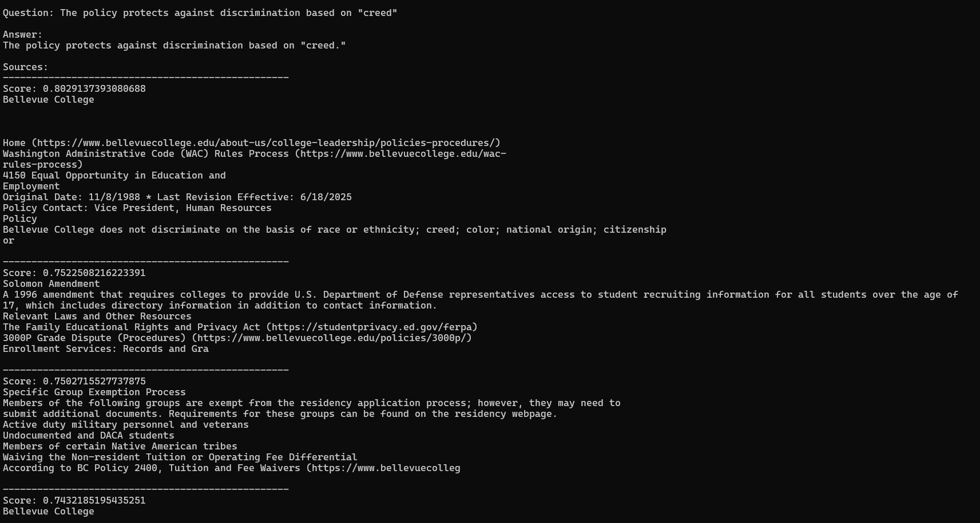
7. 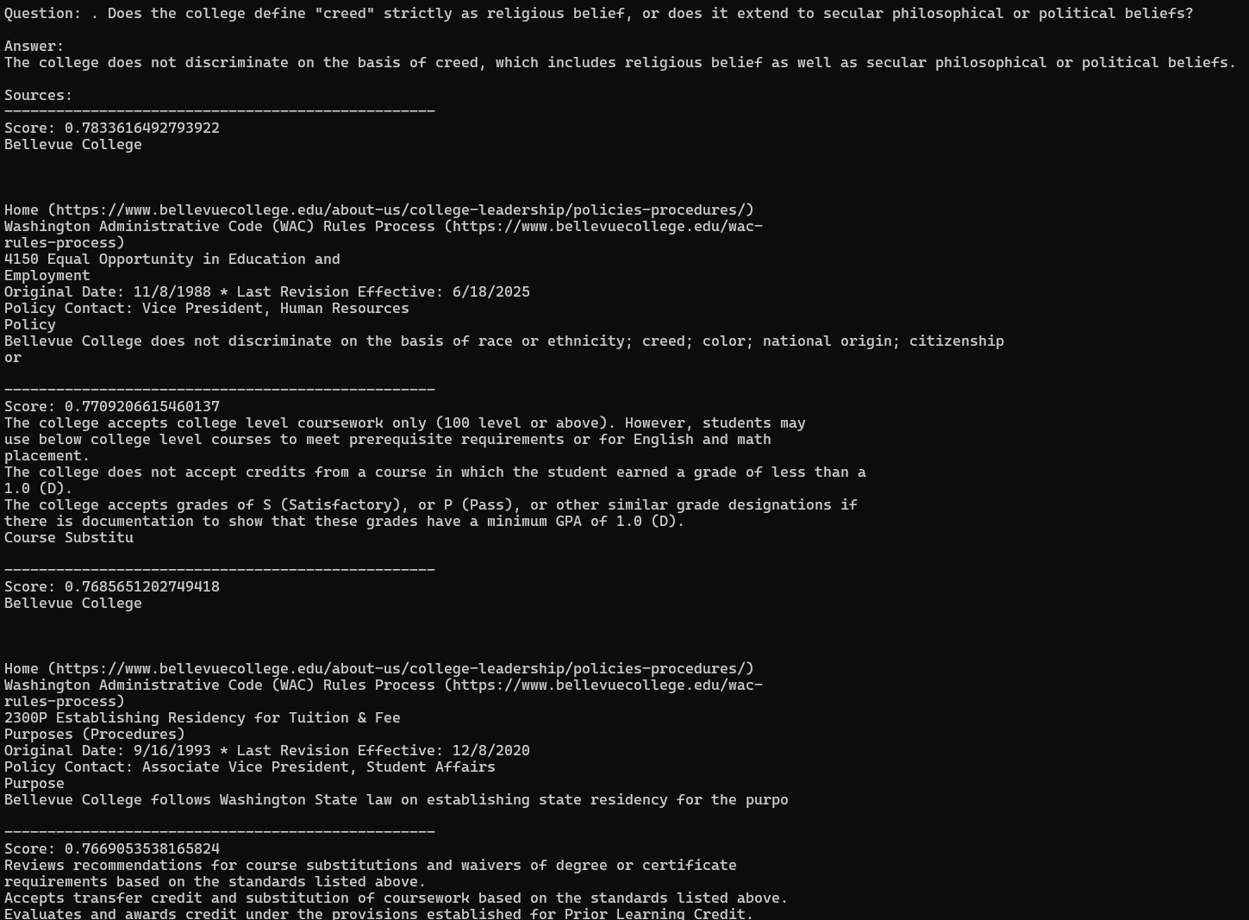
13. 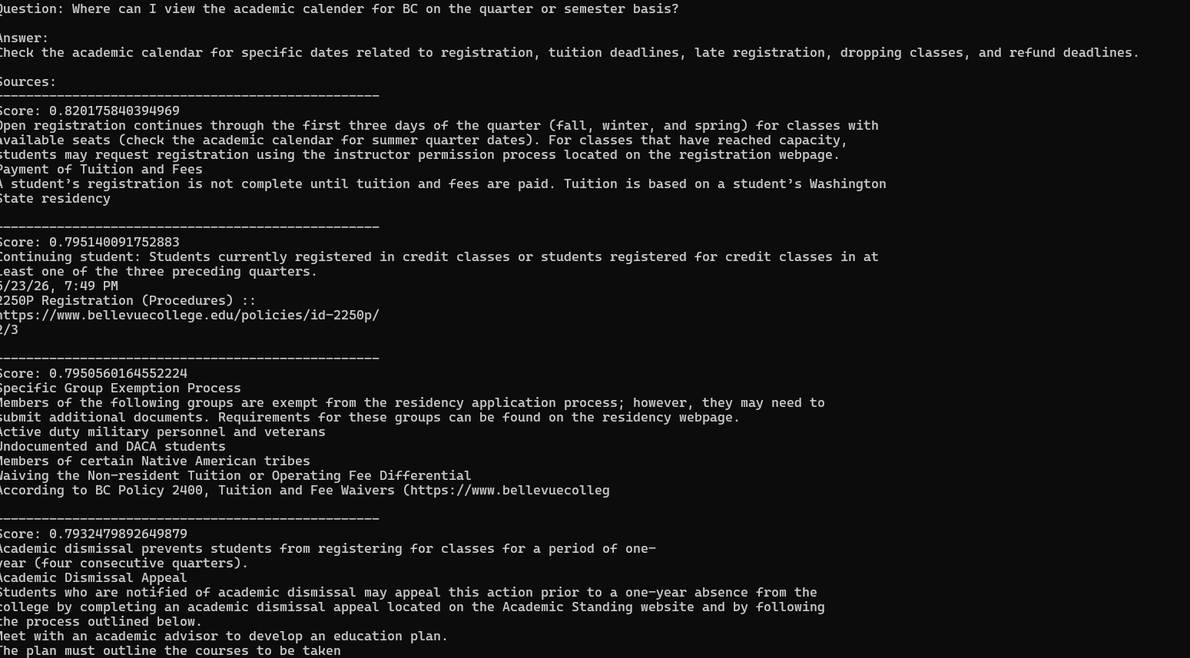
15. 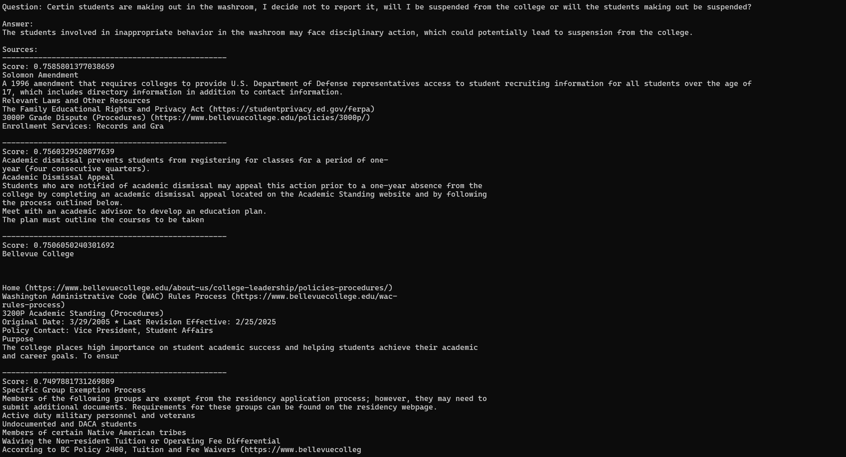
15. 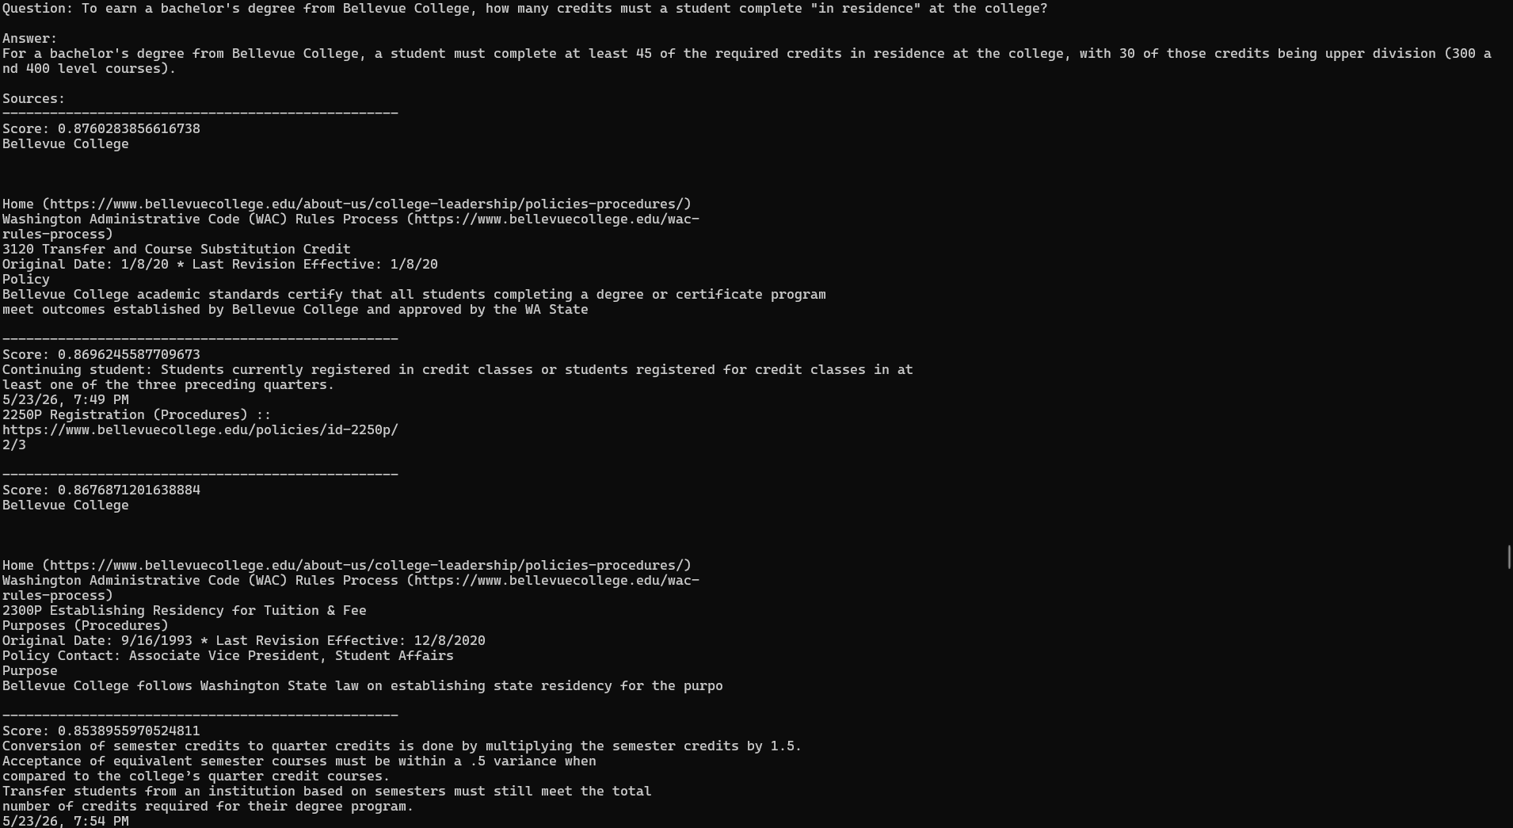
19 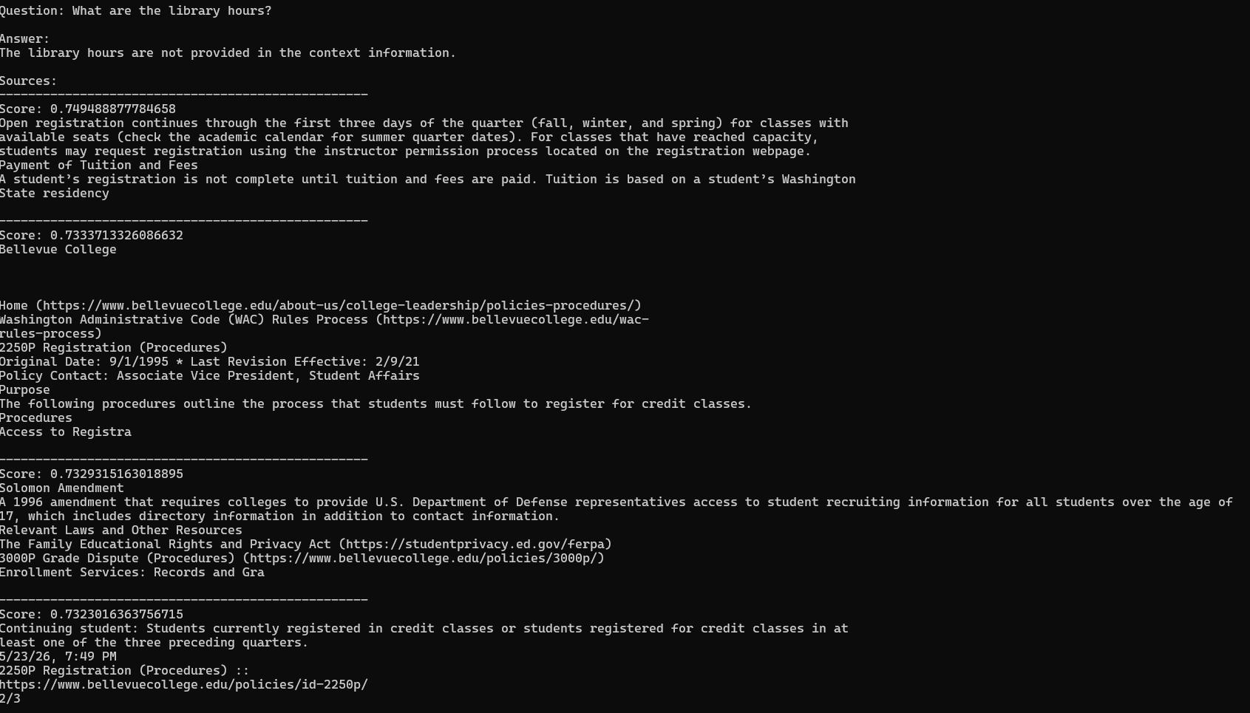
20. 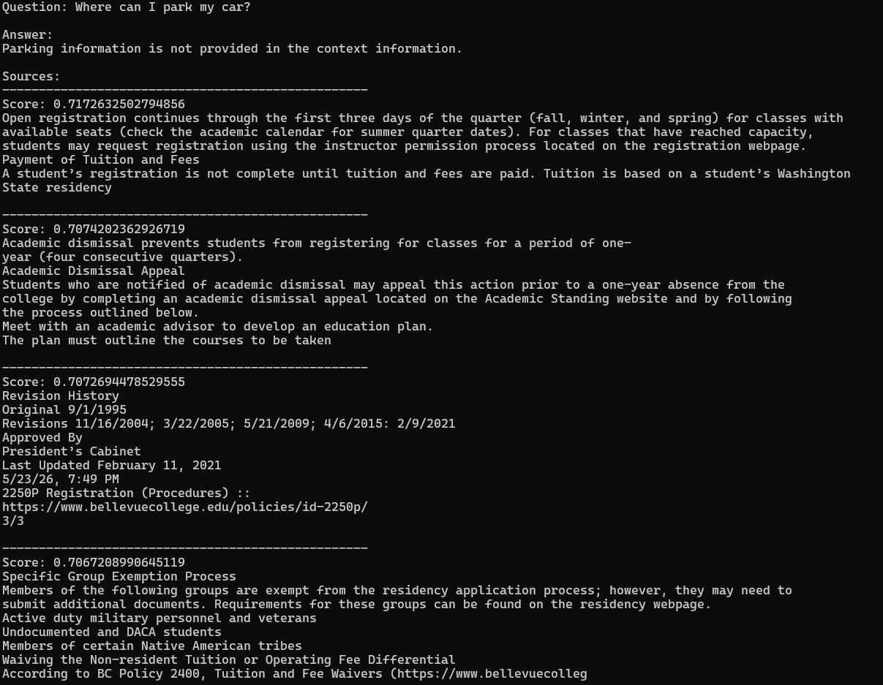
21. 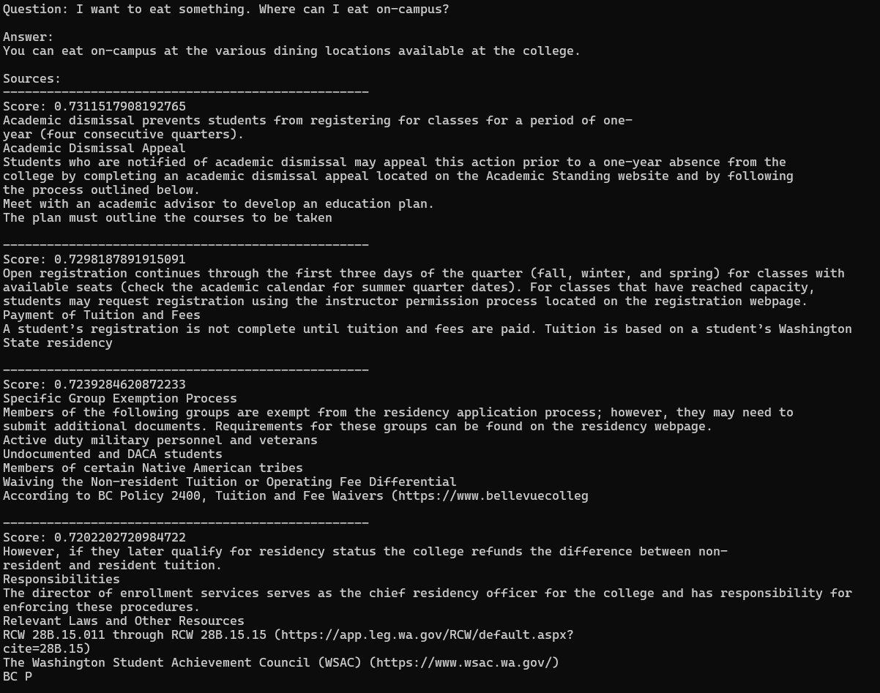
23. 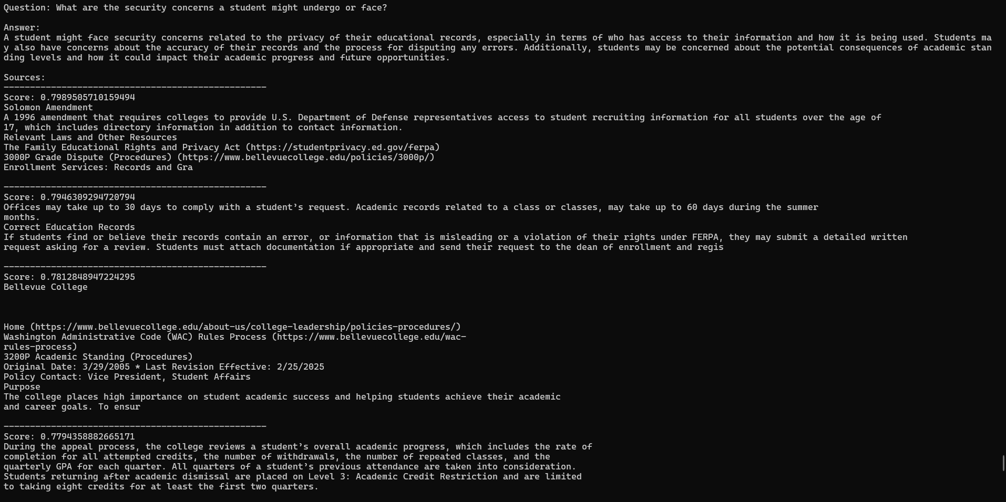
29. 